#### Netapp Data Motion Operational Readiness (OR)

|  |  |
| --- | --- |
| **Background** | Netapp provides SANs that provision NFS storage to VMWARE. A challenge for the storage team is scheduling outages when data needs to move between storage aggregates for maintenance and upgrades. Data Motion is a netapp technology that allows data to be moved without causing an outage. |
| Purpose **Description** | The purpose of this Operational Readiness is to test the simulated performance impact on a large number of VMs while Netapp Data Motion is in use.  Work with Santhana Ramasamy from the storage team to test the performance impact on virtual machines while data motion is under load. Clone many VMs, Generate some load using IO in coordination with Santhana’s activities. Make sure the VMs continue to have good performance during the test. Power down the VMs when done. |
| Analysis | Analysis will come in four ways:   1. During the tests, a tool named Whatsup will run continual pings and will capture any moments of lost pings. 2. VMWARE Performance monitors will be examined for indication of impact from the Netapp Data Motion activity 3. After the second test, Linux will be examined to see if the boot volumes turns Read-Only. 4. All VMs will be examined for blue screens and crashes. |
| Roles and Responsibilities | Kevin Gilbert – Responsible for the VMWARE environment and constructing the Operation Readiness report.  Santhana Ramasamy – Provision the storage and perform data motion activities during the test |

|  |  |  |  |  |  |  |  |  |  |  |
| --- | --- | --- | --- | --- | --- | --- | --- | --- | --- | --- |
| Document Owner / Version | |  |  |  | | --- | --- | --- | | **Author** | **Document Version** | **Date Created / Update** | | *Kevin Gilbert* | *1.0* | *5/11/2012* | | *{Engineer Name}* | *{Document Version x.x}* | *{Date}* | |

Test Infrastructure

Hardware Configuration

Three ESXi hosts will be used for this test. Each host is configured as follows:

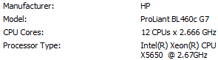

ESXi Version

VMware ESXi 5.0.0 515841

Storage Configuration

Each host has a local datastore, a nosnap, snap07, and snap14.



Network Configuration

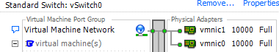

Virtual Machine Configuration

Virtual machines varied from 2 CPU to 4, and from 2GB RAM to 8GB RAM. All virtual machines used Virtual Machine Hardware Version 7 with no reservations and equal resource shares.

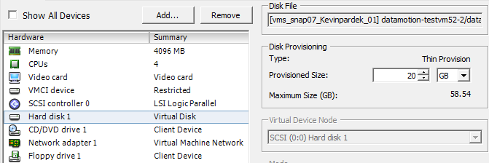

|  |  |
| --- | --- |
| VIRTUAL MACHINE | QUANTITY IN LAB |
| 2 CPU, 2GB RAM Win03R2 SP2 | 12 |
| 4 CPU, 4GB RAM Win03R2 SP2 | 9 |
| 4 CPU, 8 GB RAM Win03R2 SP2 | 46 |
| 2 CPU, 2 GB RAM SUSE 11 | 5 |

Storage Configuration

Swap forall Windows VMs is stored on vms_nosnap_Kevinpardek_01

|  |  |
| --- | --- |
| Name Of Datastore | Number of Virtual Machines |
| Vms_snap07_Kevinpardek_01 | 30 |
| Vms_snap14_Kevinpardek_01 | 42 |

Linux Mount Information

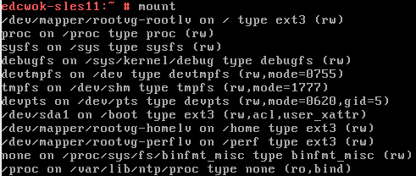

Timeout on the Linux VMs was set to 190:

/sys/class/scsi_generic/sg0/device/timeout

/sys/class/scsi_generic/sg1/device/timeout

Netapp NFS Recommended Settings

The hosts had the following recommended Netapp setting changes:

Net.TcpipHeapSize: 32

NFS.MaxVolumes:256

Net.TcpipHeapMax:128

Disk.QFullSampleSize:32

Disk.QFullThreshold:8

Nfssettings: true

Qfullsettings:true

Lab Configuration Diagram

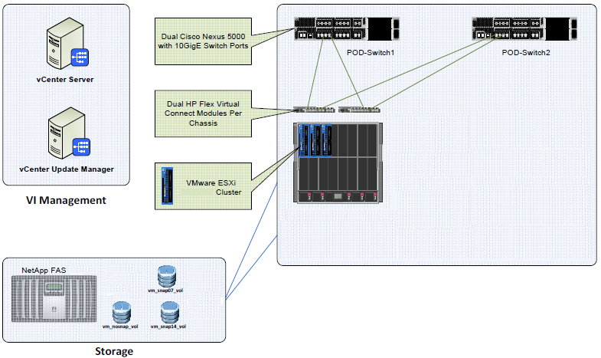

**IOMeter Labtest.icf**

Each Windows virtual machine came pre-configured with IO Meter to run upon start-up.

Version 2006.07.27

'TEST SETUP ====================================================================

'Test Description

'Run Time

' hours minutes seconds

5 5 0

'Ramp Up Time (s)

0

'Default Disk Workers to Spawn

NUMBER_OF_CPUS

'Default Network Workers to Spawn

0

'Record Results

ALL

'Worker Cycling

' start step step type

1 1 LINEAR

'Disk Cycling

' start step step type

1 1 LINEAR

'Queue Depth Cycling

' start end step step type

1 32 2 EXPONENTIAL

'Test Type

NORMAL

'END test setup

'RESULTS DISPLAY ===============================================================

'Update Frequency,Update Type

1,LAST_UPDATE

'Bar chart 1 statistic

Total I/Os per Second

'Bar chart 2 statistic

Total MBs per Second

'Bar chart 3 statistic

Average I/O Response Time (ms)

'Bar chart 4 statistic

Maximum I/O Response Time (ms)

'Bar chart 5 statistic

% CPU Utilization (total)

'Bar chart 6 statistic

Total Error Count

'END results display

'ACCESS SPECIFICATIONS =========================================================

'Access specification name,default assignment

Default,NONE

'size,% of size,% reads,% random,delay,burst,align,reply

2048,100,67,100,0,1,0,0

'Access specification name,default assignment

512B; 100% Read; 0% random,NONE

'size,% of size,% reads,% random,delay,burst,align,reply

512,100,100,0,0,1,0,0

'Access specification name,default assignment

512B; 75% Read; 0% random,NONE

'size,% of size,% reads,% random,delay,burst,align,reply

512,100,75,0,0,1,0,0

'Access specification name,default assignment

512B; 50% Read; 0% random,NONE

'size,% of size,% reads,% random,delay,burst,align,reply

512,100,50,0,0,1,0,0

'Access specification name,default assignment

512B; 25% Read; 0% random,NONE

'size,% of size,% reads,% random,delay,burst,align,reply

512,100,25,0,0,1,0,0

'Access specification name,default assignment

512B; 0% Read; 0% random,NONE

'size,% of size,% reads,% random,delay,burst,align,reply

512,100,0,0,0,1,0,0

'Access specification name,default assignment

4K; 100% Read; 0% random,NONE

'size,% of size,% reads,% random,delay,burst,align,reply

4096,100,100,0,0,1,0,0

'Access specification name,default assignment

4K; 75% Read; 0% random,NONE

'size,% of size,% reads,% random,delay,burst,align,reply

4096,100,75,0,0,1,0,0

'Access specification name,default assignment

4K; 50% Read; 0% random,NONE

'size,% of size,% reads,% random,delay,burst,align,reply

4096,100,50,0,0,1,0,0

'Access specification name,default assignment

4K; 25% Read; 0% random,NONE

'size,% of size,% reads,% random,delay,burst,align,reply

4096,100,25,0,0,1,0,0

'Access specification name,default assignment

4K; 0% Read; 0% random,NONE

'size,% of size,% reads,% random,delay,burst,align,reply

4096,100,0,0,0,1,0,0

'Access specification name,default assignment

16K; 100% Read; 0% random,NONE

'size,% of size,% reads,% random,delay,burst,align,reply

16384,100,100,0,0,1,0,0

'Access specification name,default assignment

16K; 75% Read; 0% random,NONE

'size,% of size,% reads,% random,delay,burst,align,reply

16384,100,75,0,0,1,0,0

'Access specification name,default assignment

16K; 50% Read; 0% random,NONE

'size,% of size,% reads,% random,delay,burst,align,reply

16384,100,50,0,0,1,0,0

'Access specification name,default assignment

16K; 25% Read; 0% random,NONE

'size,% of size,% reads,% random,delay,burst,align,reply

16384,100,25,0,0,1,0,0

'Access specification name,default assignment

16K; 0% Read; 0% random,NONE

'size,% of size,% reads,% random,delay,burst,align,reply

16384,100,0,0,0,1,0,0

'Access specification name,default assignment

32K; 100% Read; 0% random,NONE

'size,% of size,% reads,% random,delay,burst,align,reply

32768,100,100,0,0,1,0,0

'Access specification name,default assignment

32K; 75% Read; 0% random,NONE

'size,% of size,% reads,% random,delay,burst,align,reply

32768,100,75,0,0,1,0,0

'Access specification name,default assignment

32K; 50% Read; 0% random,NONE

'size,% of size,% reads,% random,delay,burst,align,reply

32768,100,50,0,0,1,0,0

'Access specification name,default assignment

32K; 25% Read; 0% random,NONE

'size,% of size,% reads,% random,delay,burst,align,reply

32768,100,25,0,0,1,0,0

'Access specification name,default assignment

32K; 0% Read; 0% random,NONE

'size,% of size,% reads,% random,delay,burst,align,reply

32768,100,0,0,0,1,0,0

'Access specification name,default assignment

All in one,NONE

'size,% of size,% reads,% random,delay,burst,align,reply

512,5,100,0,0,1,0,0

512,5,75,0,0,1,0,0

512,5,50,0,0,1,0,0

512,5,25,0,0,1,0,0

512,5,0,0,0,1,0,0

4096,5,100,0,0,1,0,0

4096,5,75,0,0,1,0,0

4096,5,50,0,0,1,0,0

4096,5,25,0,0,1,0,0

4096,5,0,0,0,1,0,0

16384,5,100,0,0,1,0,0

16384,5,75,0,0,1,0,0

16384,5,50,0,0,1,0,0

16384,5,25,0,0,1,0,0

16384,5,0,0,0,1,0,0

32768,5,100,0,0,1,0,0

32768,5,75,0,0,1,0,0

32768,5,50,0,0,1,0,0

32768,5,25,0,0,1,0,0

32768,5,0,0,0,1,0,0

'Access specification name,default assignment

Copy of 4K; 100% Read; 0% random (1),NONE

'size,% of size,% reads,% random,delay,burst,align,reply

1024,100,100,0,0,1,0,0

'END access specifications

'MANAGER LIST ==================================================================

'Manager ID, manager name

1,LABTESTVM1

'Manager network address

127.0.0.1

'Worker

Worker 1

'Worker type

DISK

'Default target settings for worker

'Number of outstanding IOs,test connection rate,transactions per connection

1,ENABLED,0

'Disk maximum size,starting sector

0,0

'End default target settings for worker

'Assigned access specs

512B; 100% Read; 0% random

'End assigned access specs

'Target assignments

'Target

C:

'Target type

DISK

'End target

'End target assignments

'End worker

'Worker

Worker 1

'Worker type

DISK

'Default target settings for worker

'Number of outstanding IOs,test connection rate,transactions per connection

1,ENABLED,1

'Disk maximum size,starting sector

0,0

'End default target settings for worker

'Assigned access specs

Copy of 4K; 100% Read; 0% random (1)

'End assigned access specs

'Target assignments

'Target

C:

'Target type

DISK

'End target

'End target assignments

'End worker

'End manager

'END manager list

Version 2006.07.27

|  |  |
| --- | --- |
| Test - 1 | *Test Data Motion* |
| **Long Description** | *Perform a live migration test of Netapp Data Motion* |
| **Purpose** | *Test the impact on virtual machines during a data motion activity* |
| **Required Result** | *No impact to virtual machines* |
| **Actual Result** | *Success* |
|  |  |

**Conclusion:**

We performed the tests several times over a period of time. On the early morning of May 9 we had success with no I/O. On the evening of May 10 we had success with I/O.

Initially we planned to run 70 virtual machines during the test. However, that caused the Netapp filer’s CPU utilization to be too high. Instead, on May 10 we ran 6 virtual machines producing I/O, and 5 Linux SUSE that were not producing I/O so that we could lower the filer’s CPU utilization.

During the tests, I attempted to browse the datastores and to log into the virtual machines and open folders on the C: drive. I was able to do this with no problems. I also monitored the servers with WhatsUpGold, which detected no problems. I monitored the server’s VMWARE performance graphs and they showed no indication of anything happening. No virtual machines had blue screens or crashes. None of the Linux drives/partitions showed any impact.

Santhana noted the following take away points:

1. *Filer CPU/Disk should be normal*
   1. *CPU load should be lessthan 70% for both source and target filers*
   2. *Disk utilization should be less than 65% (max of 70%)*
2. *Need to check the vfiler root volume frequently and set the volume size manually above 10% of the original size to avoid last minutes space issue during the copy*
3. *During the pre-stage cutover time, there will be a number of samples happening and need to make sure all the above conditions are normal.*